**Manual Testing for Final Project – Week 4**

* Clicking on “Get a look” should take you to the template page, showing you the first template.

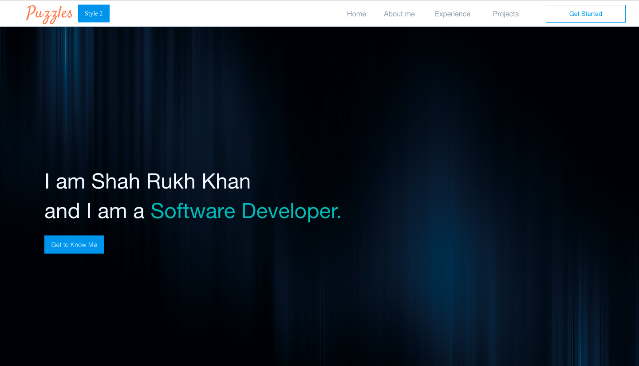

* Going to Style 2 should take you to the second portfolio design page.

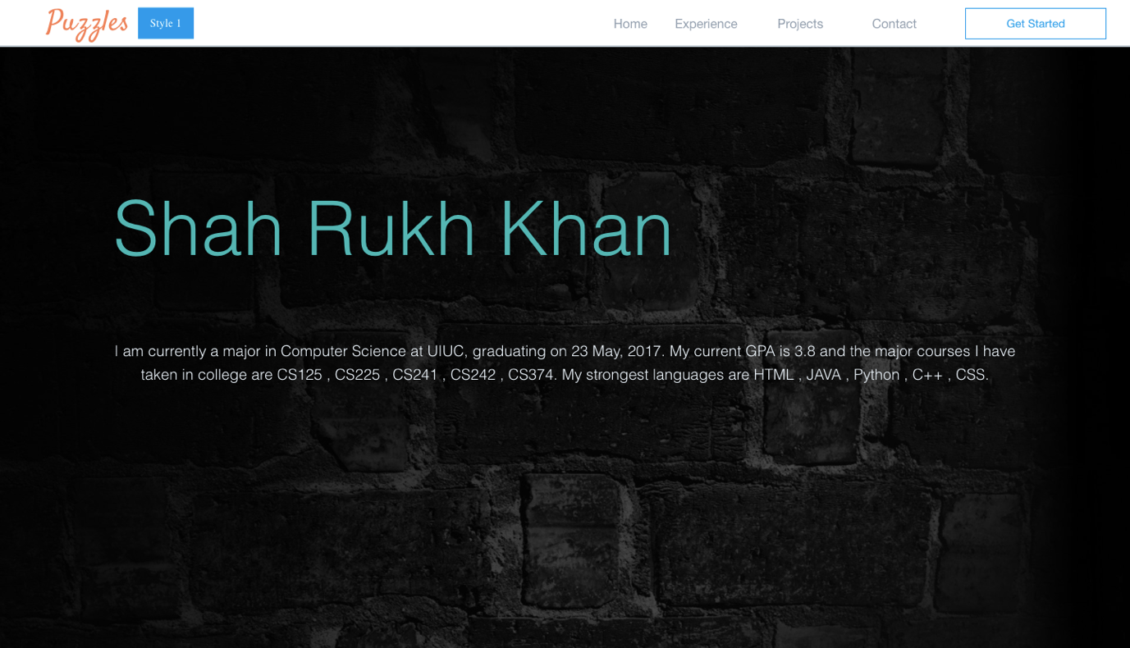

* On the following Experience Page the details should be displayed on hover.

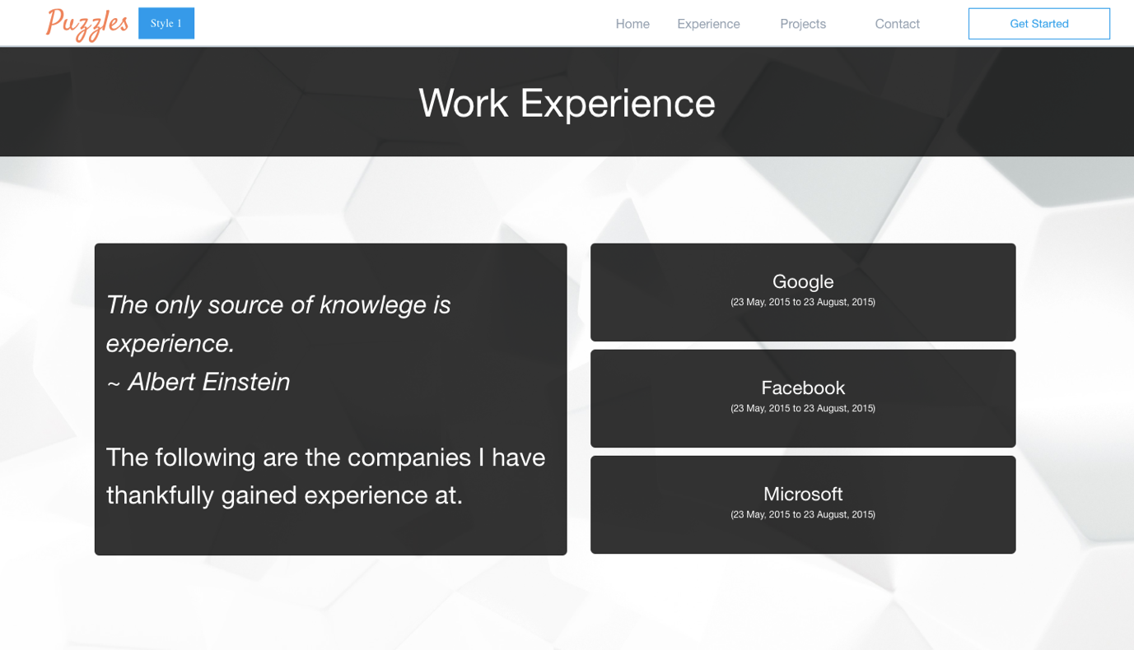

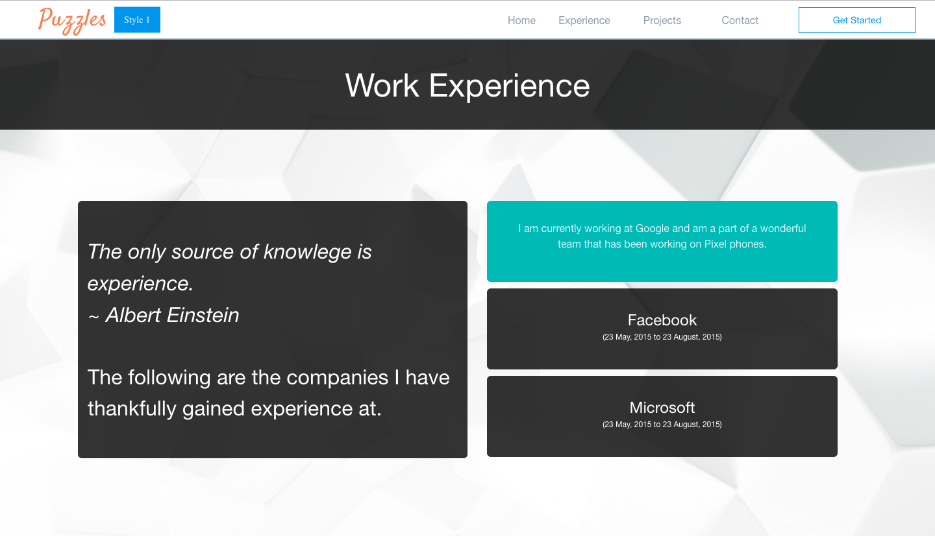

* On the following Projects Page details of the project should be displayed on hover.

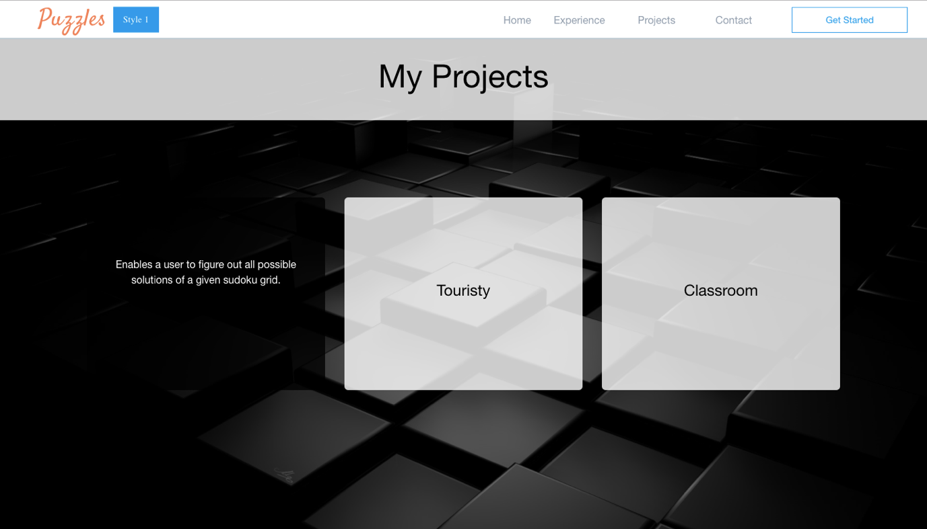

* The contact page should look as follows:

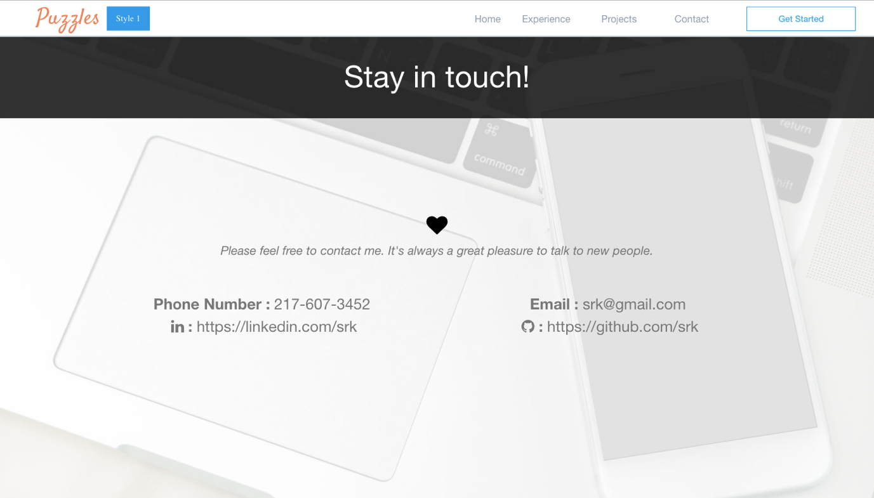

* The second template is dynamic as well.

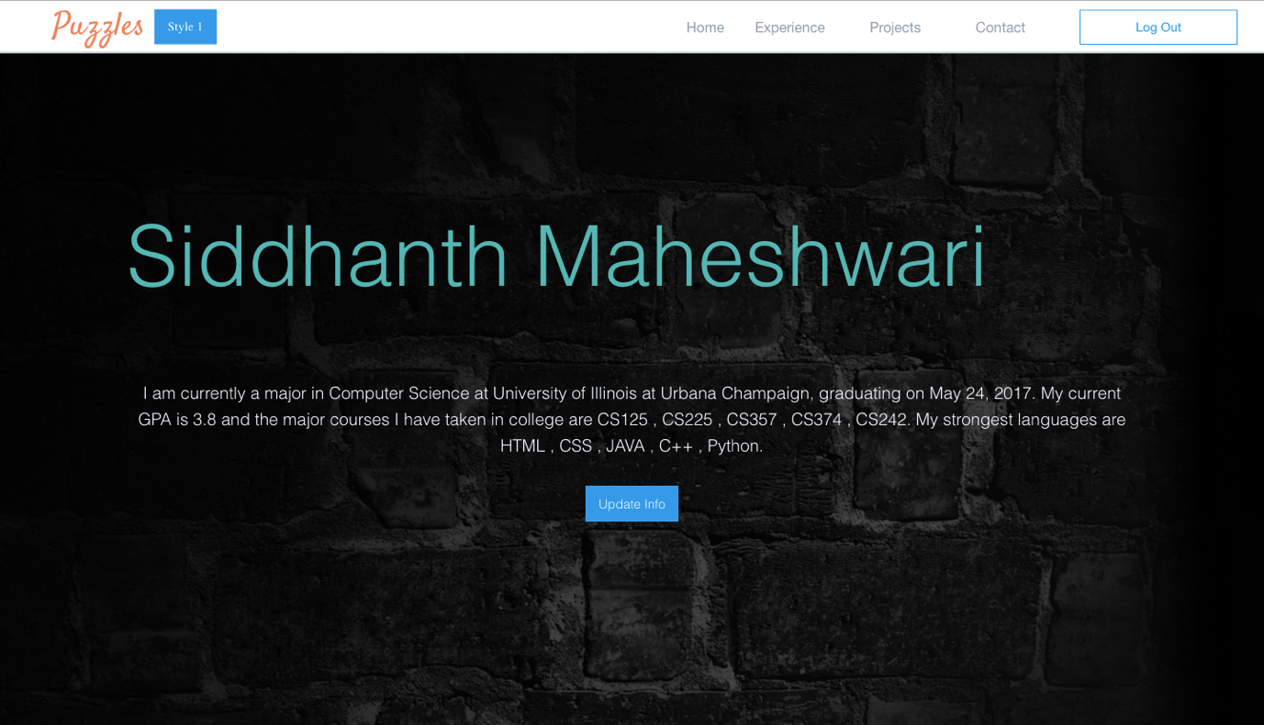

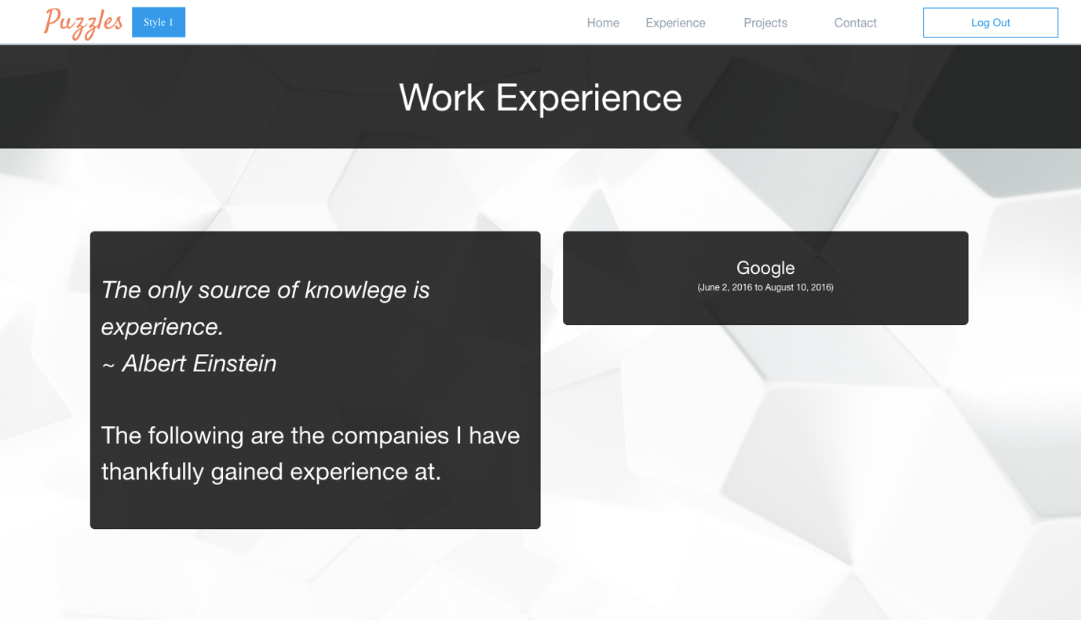

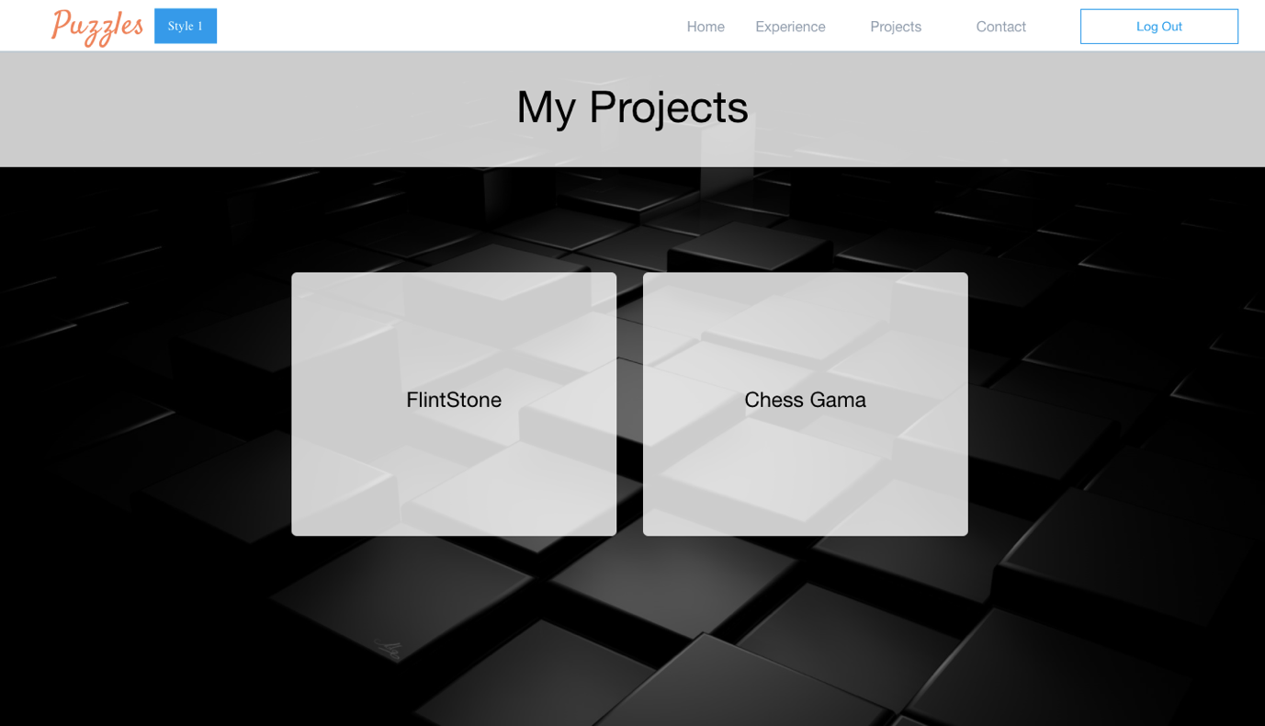

* The following are the steps to update an information:

1. Suppose I want to edit the phone number here

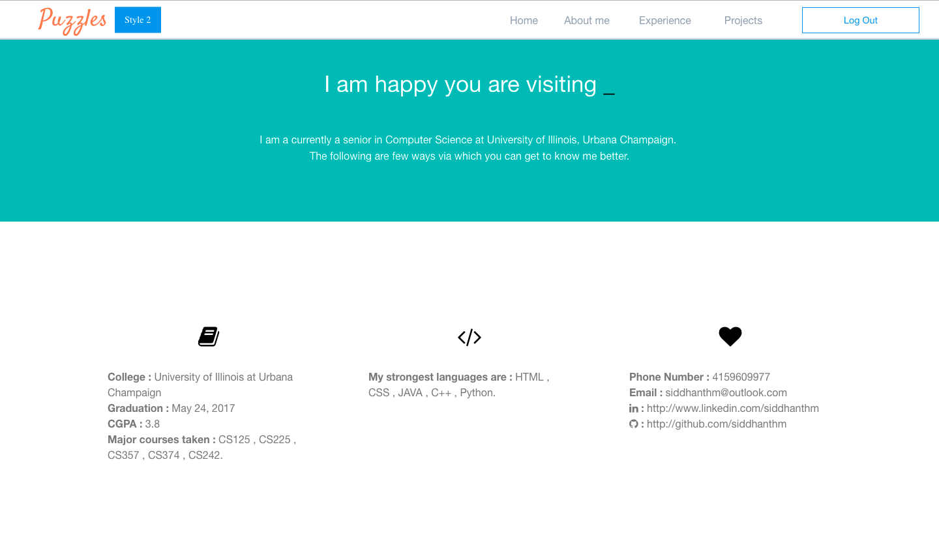

1. I need to ensure I am logged in and I click on update information

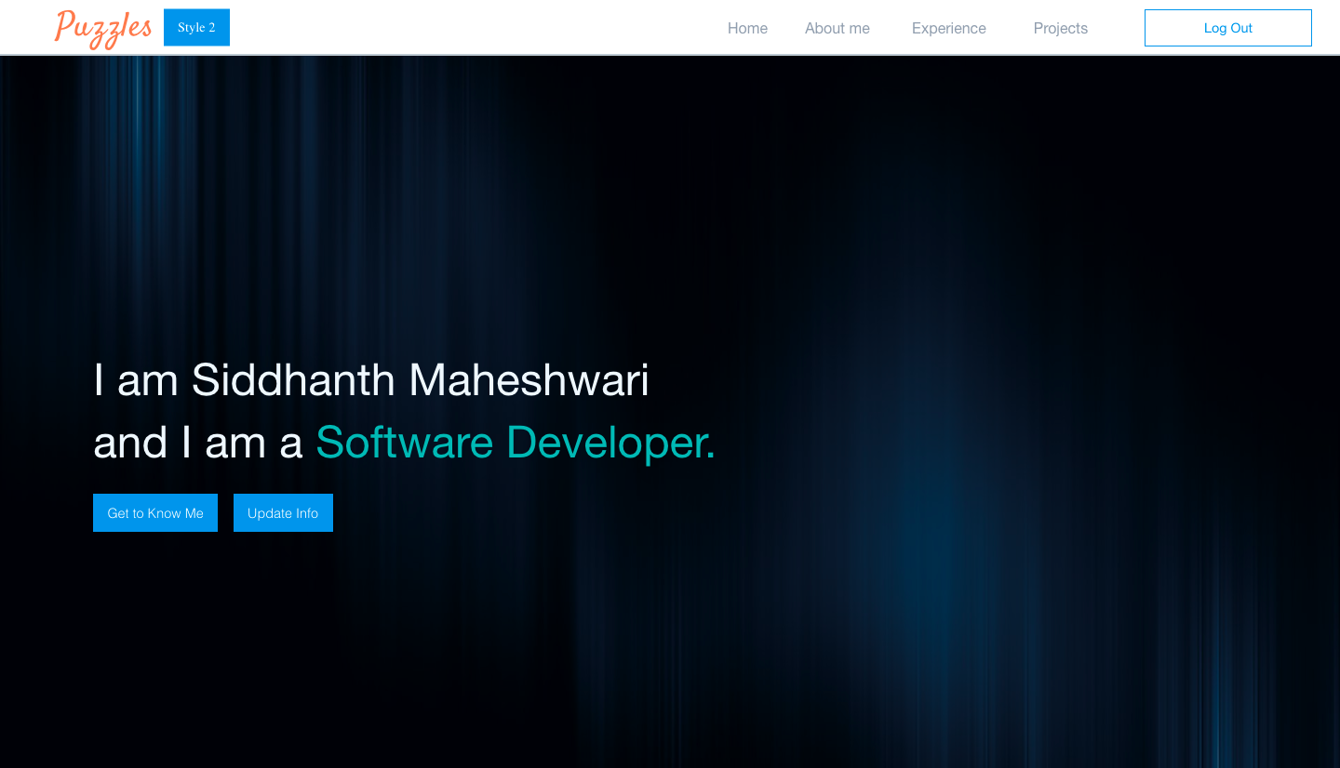

1. I can select I need to update Basic Information.

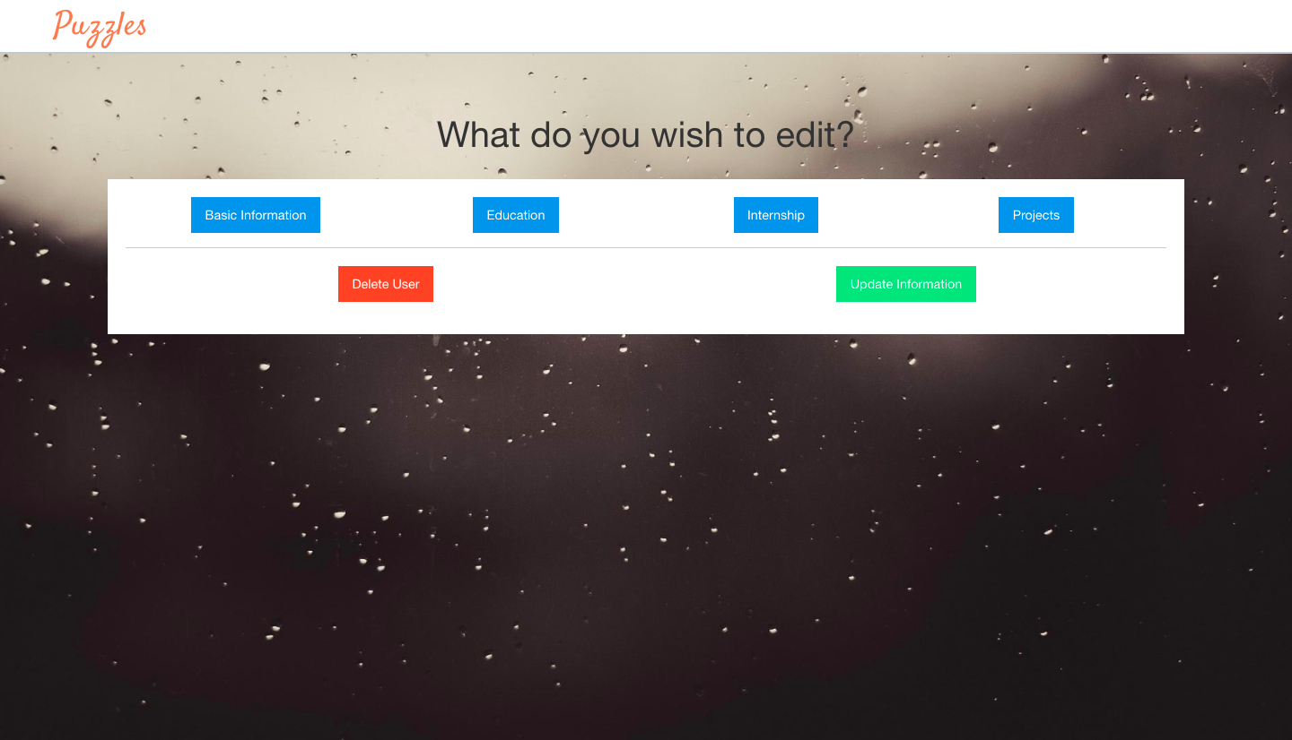

1. The information should be pre-filled.

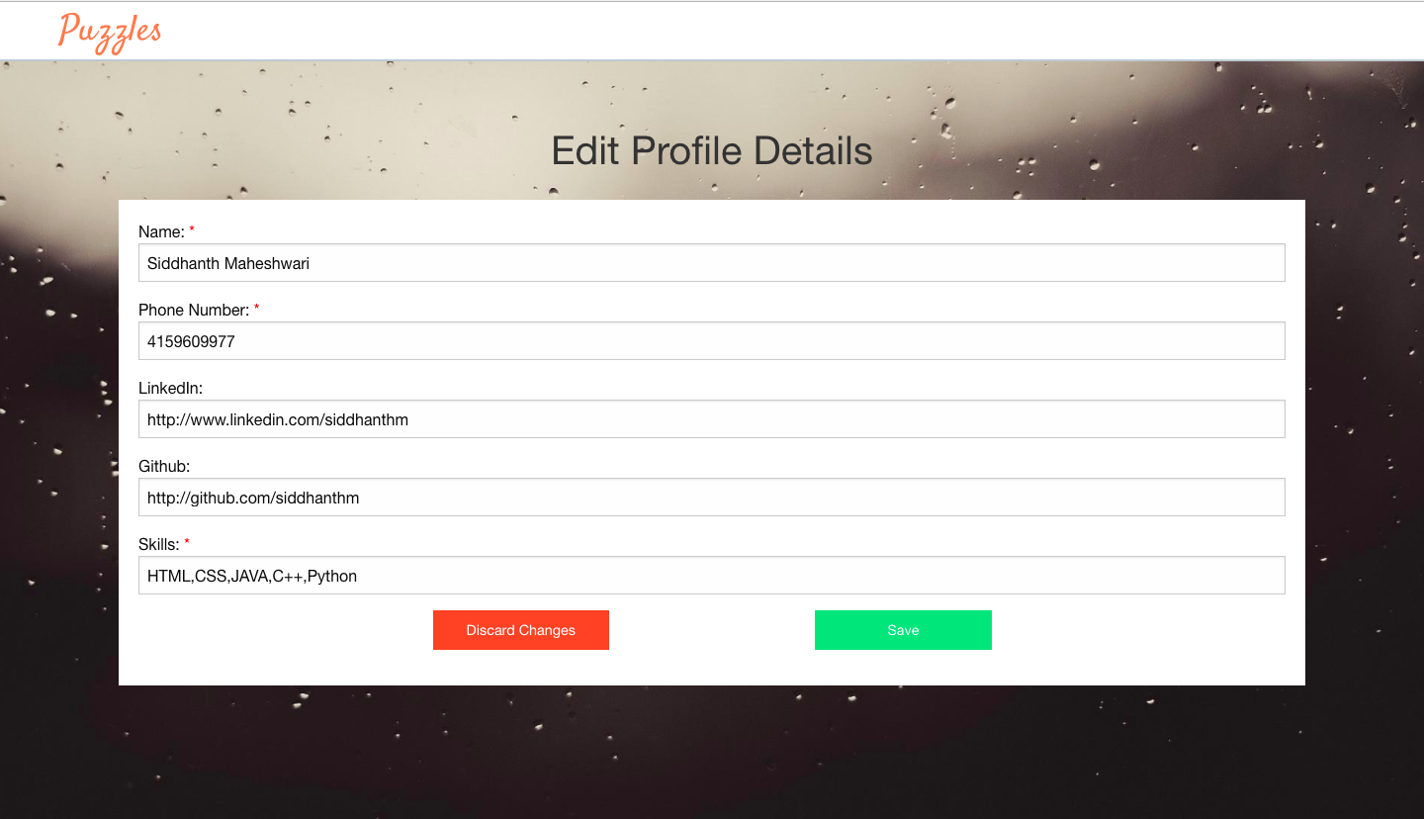

1. I can go ahead and edit the number and click on save and then on update.

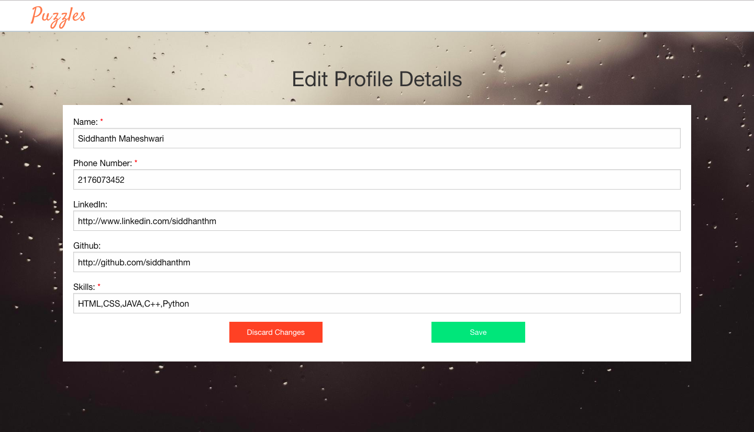

1. The phone number should now be updated.

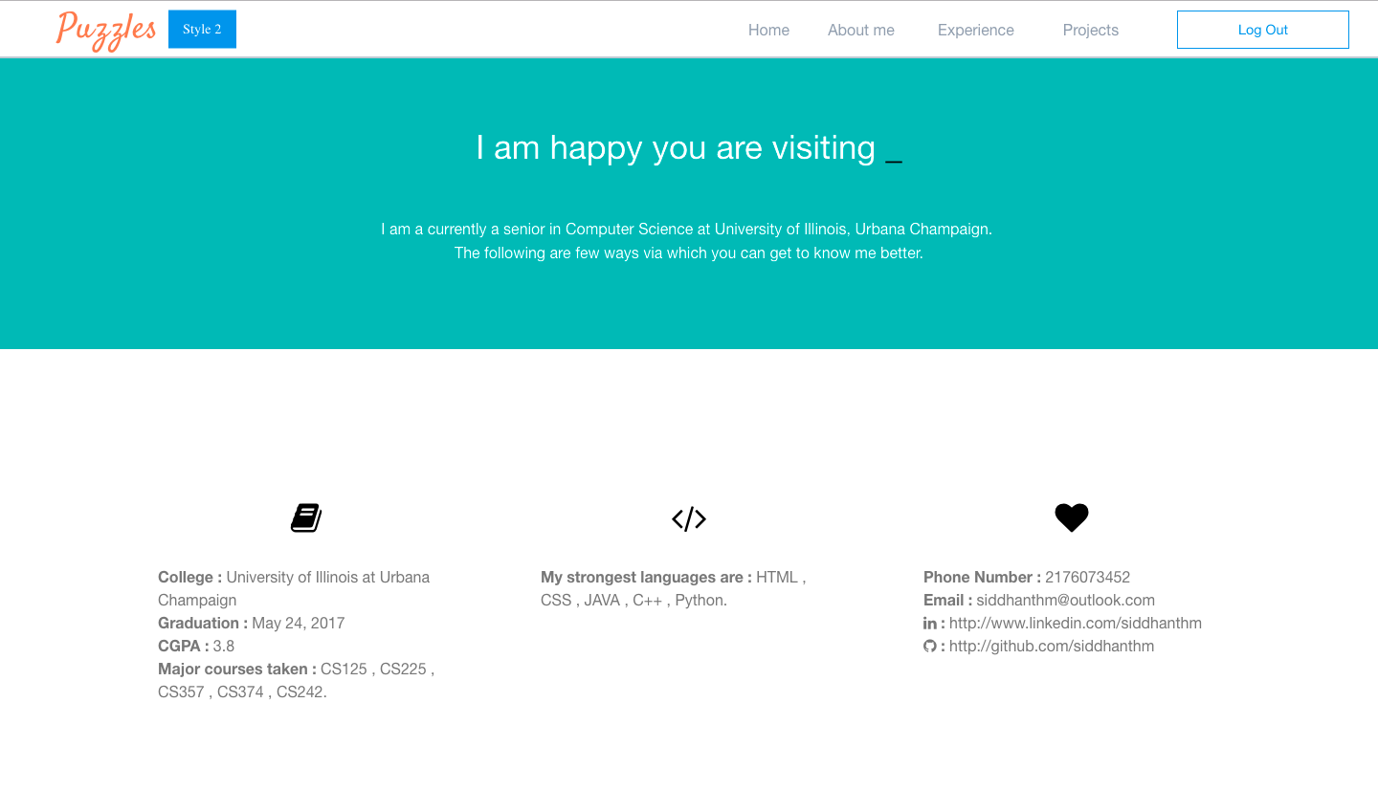

* For the flow of the page, once you log in you should be able to see the update info button on your profile and the Get Started on top right should be replaced by logout.



* You should be able to view the same for second template as well if you are logged in.

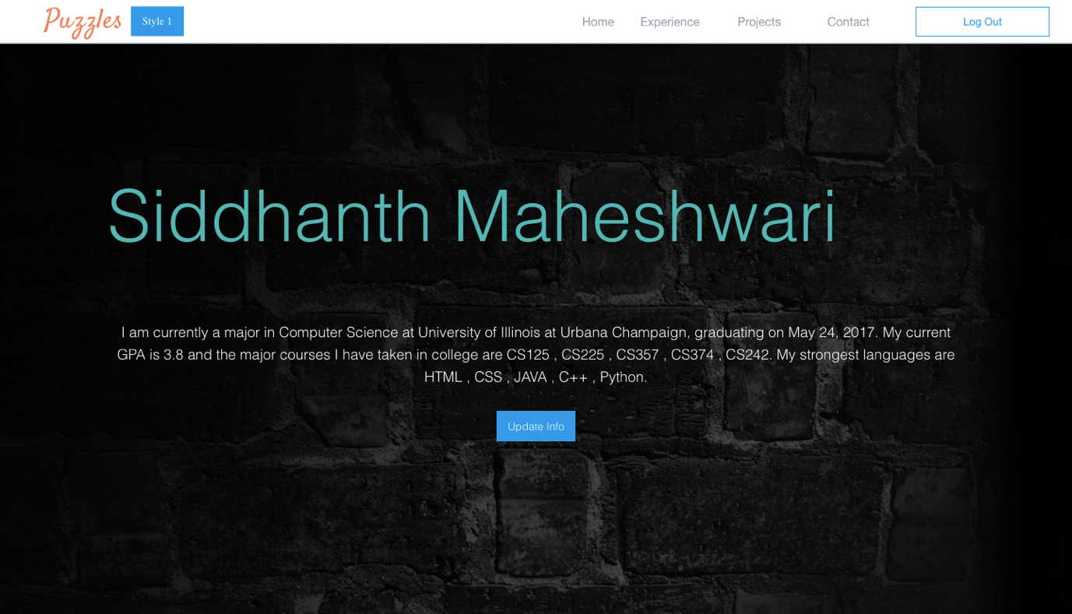

* The Update Info button shouldn’t appear on the profiles of other people.

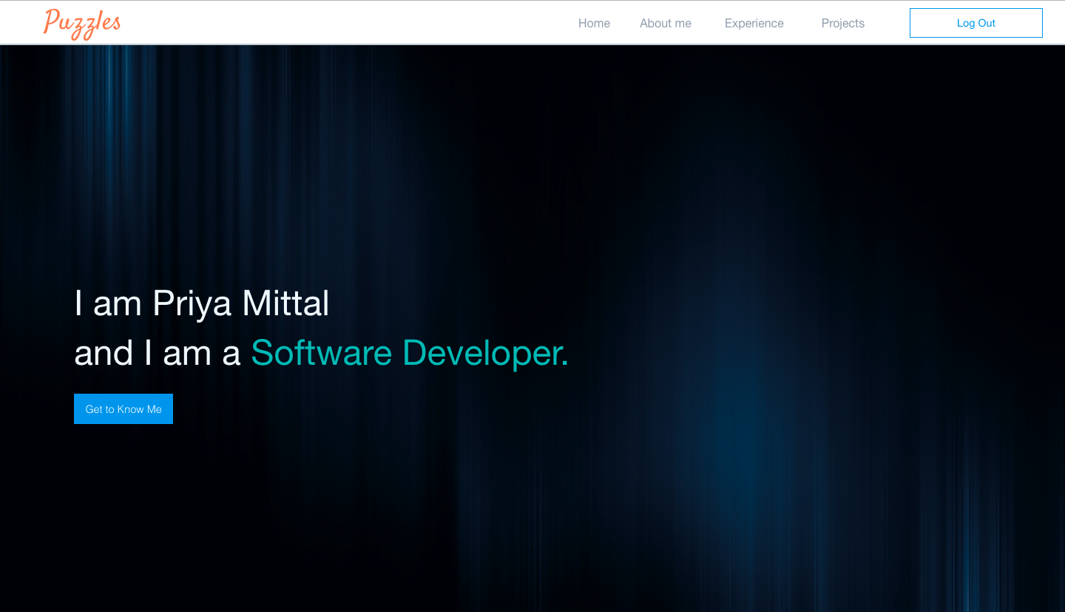

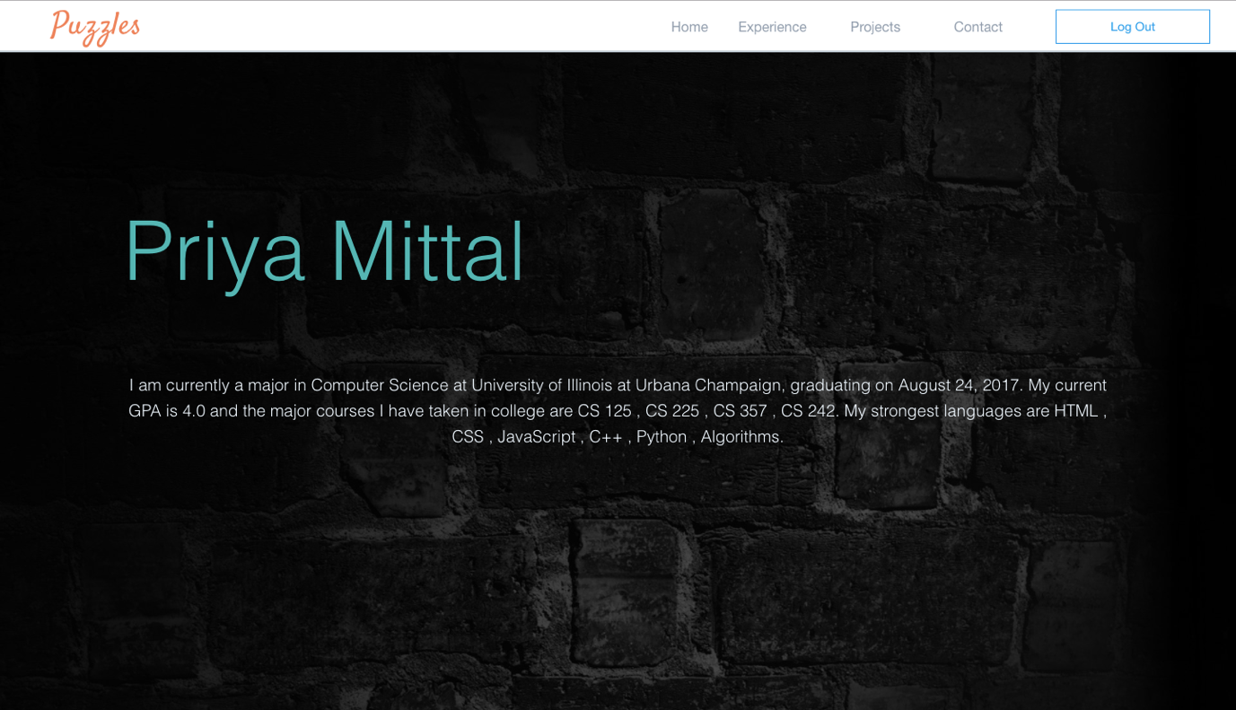

* On the home page Join and Log In button should be replaced with View Profile and Logout.

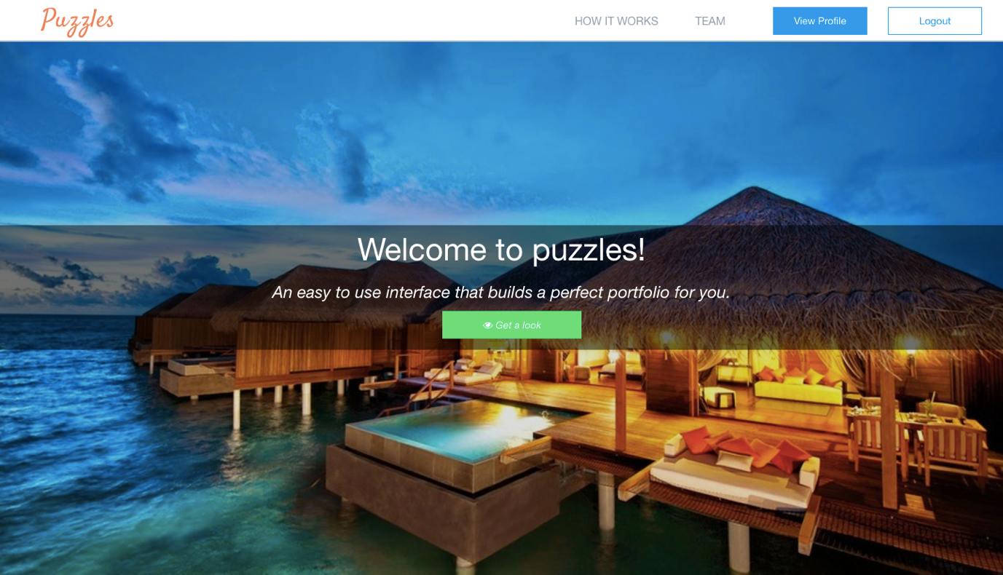

* Clicking on view profile should take you to your portfolio in the original template.



* Clicking on Log Out should take you back to the home page.

